4.3 Perintah untuk Membaca Berkas Citra

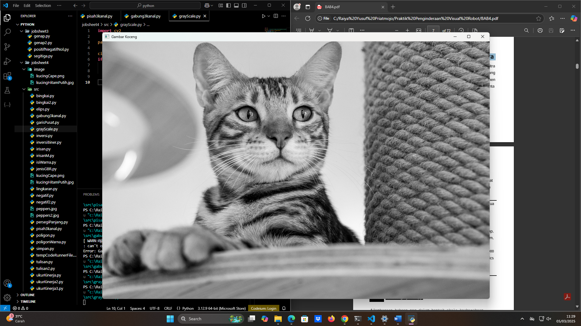

|  |
| --- |
| File : grayscale.py  **import** cv2  path_image **=** r"C:\Raiya Yusuf Priatmojo\Praktik Penginderaan Visual Robot\python\jobsheet4\image\kucingHitamPutih.jpg"  citra **=** cv2.imread(path_image, cv2.IMREAD_GRAYSCALE)  **if** citra **is** **not** None:      cv2.imshow('Gambar Koceng', citra)      cv2.waitKey(0) |

4.6 Cara Mendapatkan Informasi Mengenai Citra

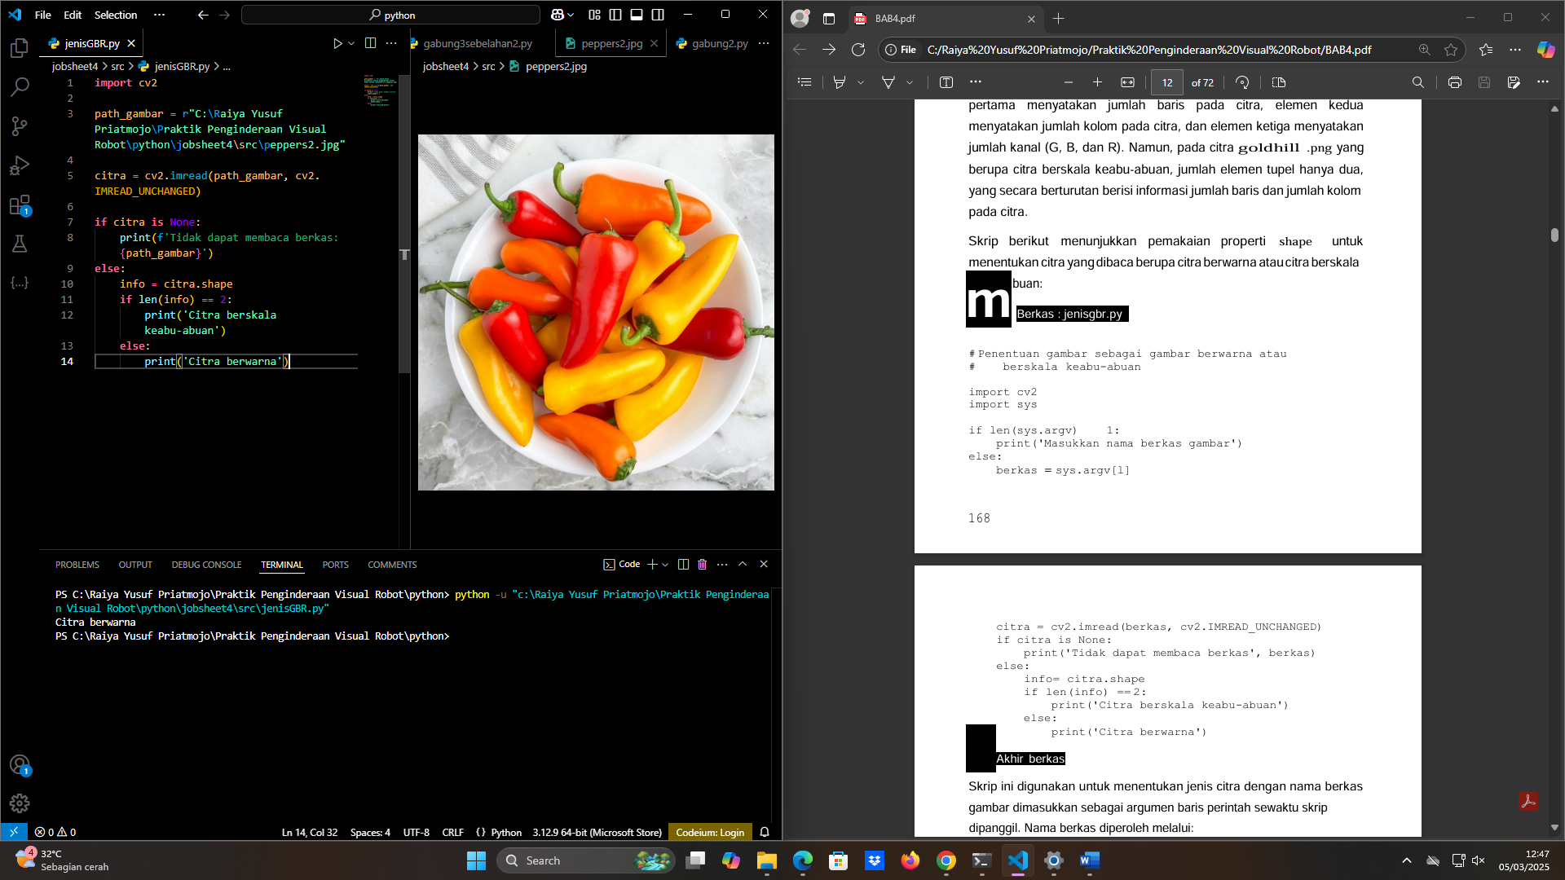

|  |
| --- |
| File : jenisRGB.py  **import** cv2  path_gambar **=** r"C:\Raiya Yusuf Priatmojo\Praktik Penginderaan Visual Robot\python\jobsheet4\src\peppers2.jpg"  citra **=** cv2.imread(path_gambar, cv2.IMREAD_UNCHANGED)  **if** citra **is** None:      print(f'Tidak dapat membaca berkas: {path_gambar}')  **else**:      info **=** citra.shape  **if** len(info) **==** 2:          print('Citra berskala keabu-abuan')  **else**:          print('Citra berwarna') |

4.7 Pengolahan Citra Berbasis Piksel

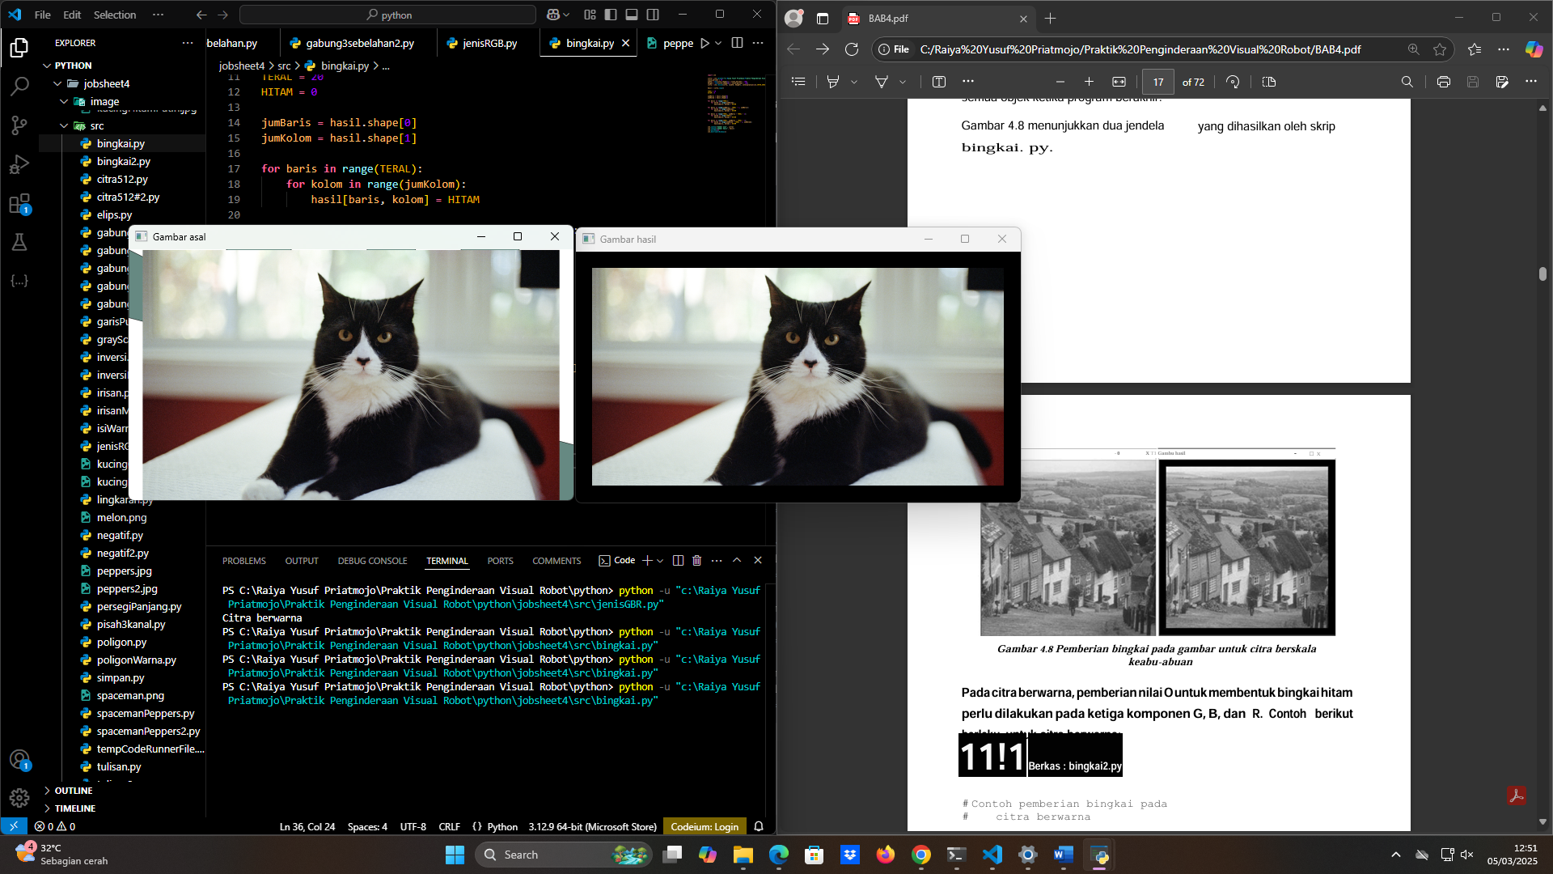

|  |
| --- |
| File : bingkai.py  **import** cv2  citra **=** cv2.imread(r"C:\Raiya Yusuf Priatmojo\Praktik Penginderaan Visual Robot\python\jobsheet4\src\kucingCape.png")  scale_percent **=** 50  width **=** int(citra.shape[1] **\*** scale_percent **/** 100)  height **=** int(citra.shape[0] **\*** scale_percent **/** 100)  citra **=** cv2.resize(citra, (width, height), **interpolation=**cv2.INTER_AREA)  hasil **=** citra.copy()  TERAL **=** 20  HITAM **=** 0  jumBaris **=** hasil.shape[0]  jumKolom **=** hasil.shape[1]  **for** baris **in** range(TERAL):  **for** kolom **in** range(jumKolom):          hasil[baris, kolom] **=** HITAM  **for** baris **in** range(jumBaris **-** TERAL **-** 1, jumBaris):  **for** kolom **in** range(jumKolom):          hasil[baris, kolom] **=** HITAM  **for** baris **in** range(TERAL, jumBaris **-** TERAL **-** 1):  **for** kolom **in** range(TERAL):          hasil[baris, kolom] **=** HITAM  **for** baris **in** range(TERAL, jumBaris **-** TERAL **-** 1):  **for** kolom **in** range(jumKolom **-** TERAL **-** 1, jumKolom):          hasil[baris, kolom] **=** HITAM  cv2.imshow('Gambar asal', citra)  cv2.imshow('Gambar hasil', hasil)  cv2.waitKey(0)  cv2.destroyAllWindows() |

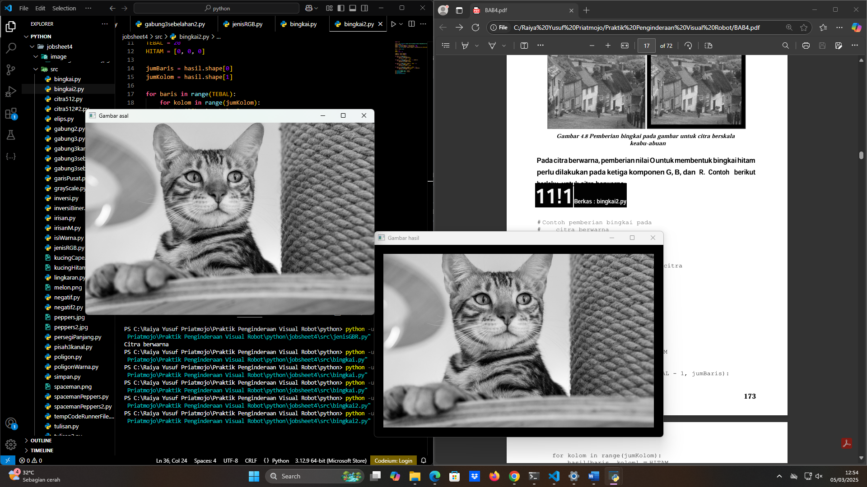

|  |
| --- |
| File : bingkai2.py  **import** cv2  citra **=** cv2.imread(r"C:\Raiya Yusuf Priatmojo\Praktik Penginderaan Visual Robot\python\jobsheet4\src\kucingHitamPutih.jpg")  scale_percent **=** 50  width **=** int(citra.shape[1] **\*** scale_percent **/** 100)  height **=** int(citra.shape[0] **\*** scale_percent **/** 100)  citra **=** cv2.resize(citra, (width, height), **interpolation=**cv2.INTER_AREA)  hasil **=** citra.copy()  TEBAL **=** 20  HITAM **=** [0, 0, 0]  jumBaris **=** hasil.shape[0]  jumKolom **=** hasil.shape[1]  **for** baris **in** range(TEBAL):  **for** kolom **in** range(jumKolom):          hasil[baris, kolom] **=** HITAM  **for** baris **in** range(jumBaris **-** TEBAL **-** 1, jumBaris):  **for** kolom **in** range(jumKolom):          hasil[baris, kolom] **=** HITAM  **for** baris **in** range(TEBAL, jumBaris **-** TEBAL **-** 1):  **for** kolom **in** range(TEBAL):          hasil[baris, kolom] **=** HITAM  **for** baris **in** range(TEBAL, jumBaris **-** TEBAL **-** 1):  **for** kolom **in** range(jumKolom **-** TEBAL **-** 1, jumKolom):          hasil[baris, kolom] **=** HITAM  cv2.imshow('Gambar asal', citra)  cv2.imshow('Gambar hasil', hasil)  cv2.waitKey(0)  cv2.destroyAllWindows() |

4.8 Penggunaan Irisan untuk Memilih Area dalam Citra

Penggunaan irisan untuk memperoleh suatu bagian pada citra

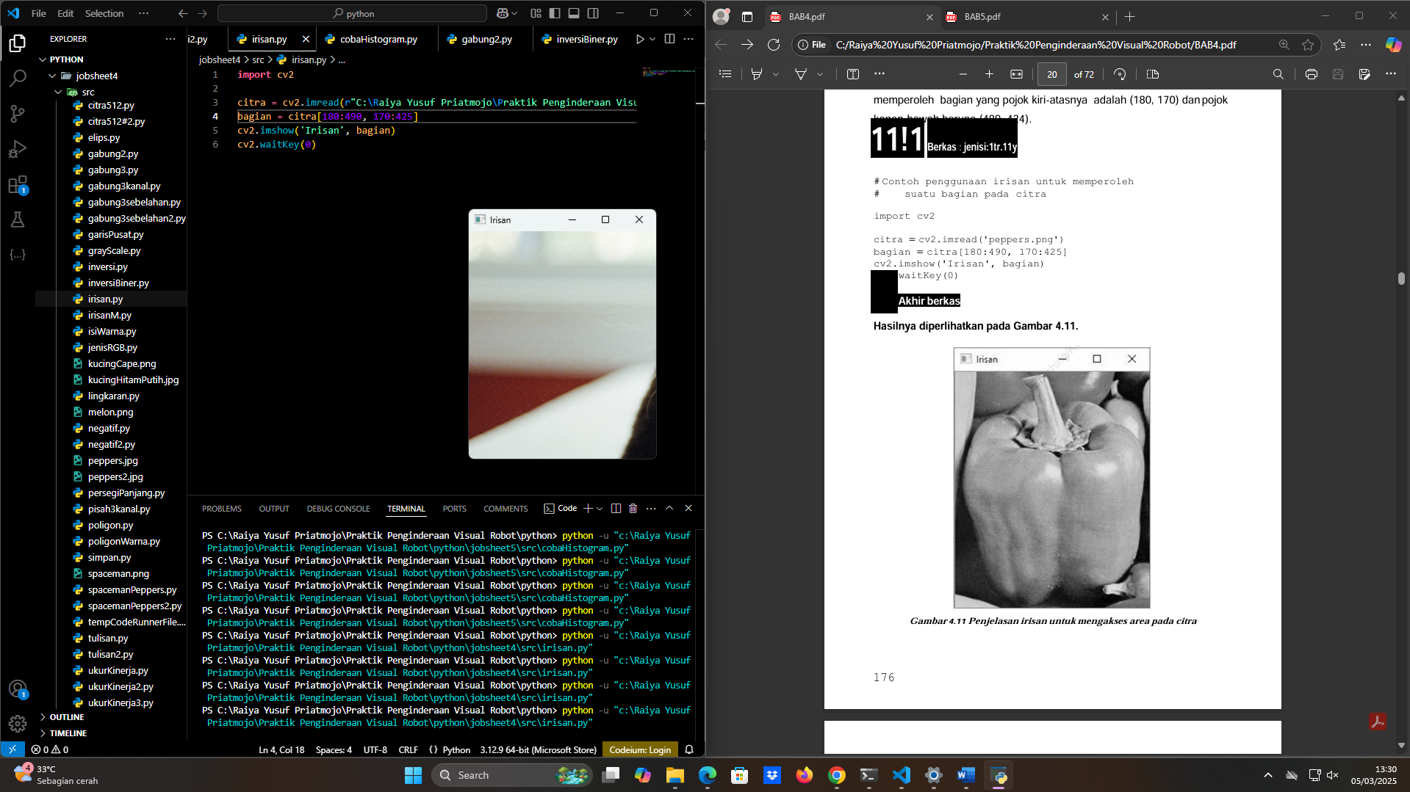

|  |
| --- |
| File : irisan.py  **import** cv2  citra **=** cv2.imread(r"C:\Raiya Yusuf Priatmojo\Praktik Penginderaan Visual Robot\python\jobsheet4\src\kucingCape.png")  bagian **=** citra[180:490, 170:425]  cv2.imshow('Irisan', bagian)  cv2.waitKey(0) |

Hasil pengubahan area pada citra melalui irisan

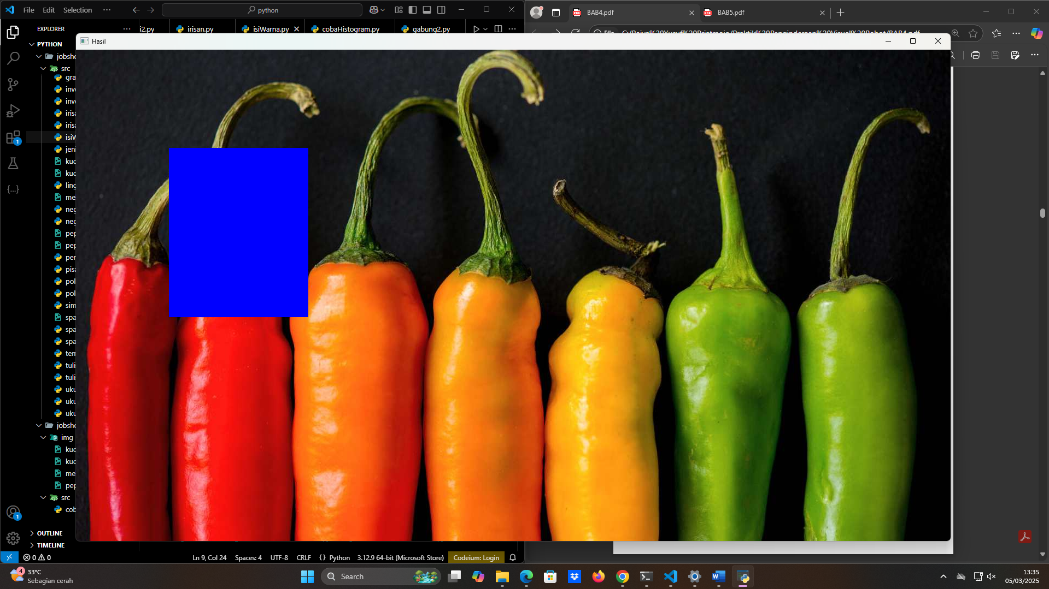

|  |
| --- |
| File : isiWarna.py  **import** cv2  citra **=** cv2.imread(r"C:\Raiya Yusuf Priatmojo\Praktik Penginderaan Visual Robot\python\jobsheet4\src\peppers.jpg")  citra[180:490, 170:425] **=** [255, 0, 0]  cv2.imshow('Hasil', citra)  cv2.waitKey(0)  cv2.destroyAllWindows() |